Creating procedure for add row in department:

CREATE OR REPLACE PROCEDURE add_employee (

e_id IN employee2.emp_id%TYPE,

e_name IN employee2.emp_name%TYPE

)

IS

BEGIN

INSERT INTO employee2 (emp_id, emp_name)

VALUES (e_id, e_name);0

END;

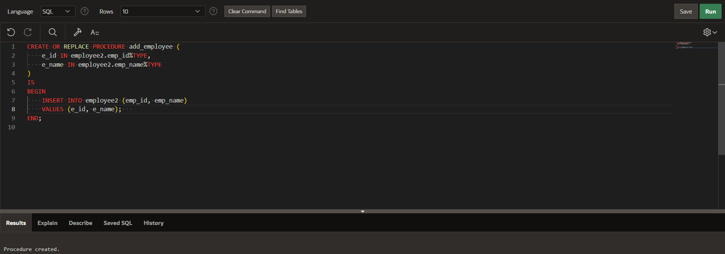

Intiating procedure:  
begin

add_employee(1010,'mahummad');

end;

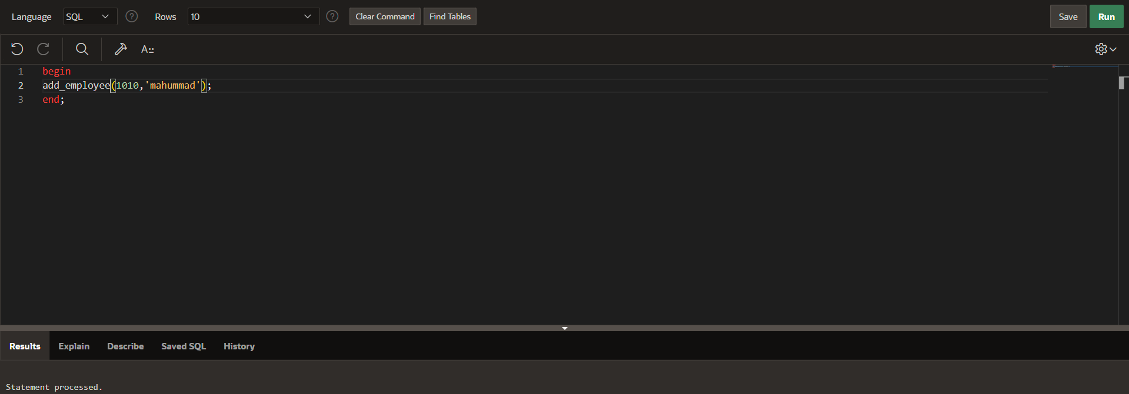

Displaying table:

Select *from employee2;

